**CAPITAL CULTURE HOUSE**

**Madrid**

Personal Exhibition called “Eternal Dream” at Medina Art Gallery in Rome, Italy 2022.

Exhibited paintings “Scared Insite” and “Liberating” below.

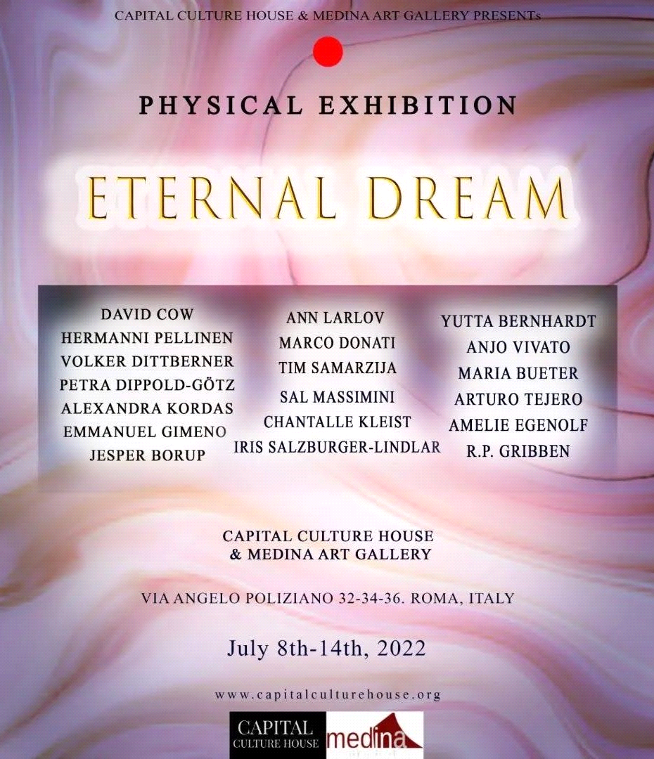

***DOUBLE CLICK ON THE MP4 FILE.***



Exhibited painting “Scared Insite” Acrylic

and Oil Pastel on Canvas 100 x 100 cm.

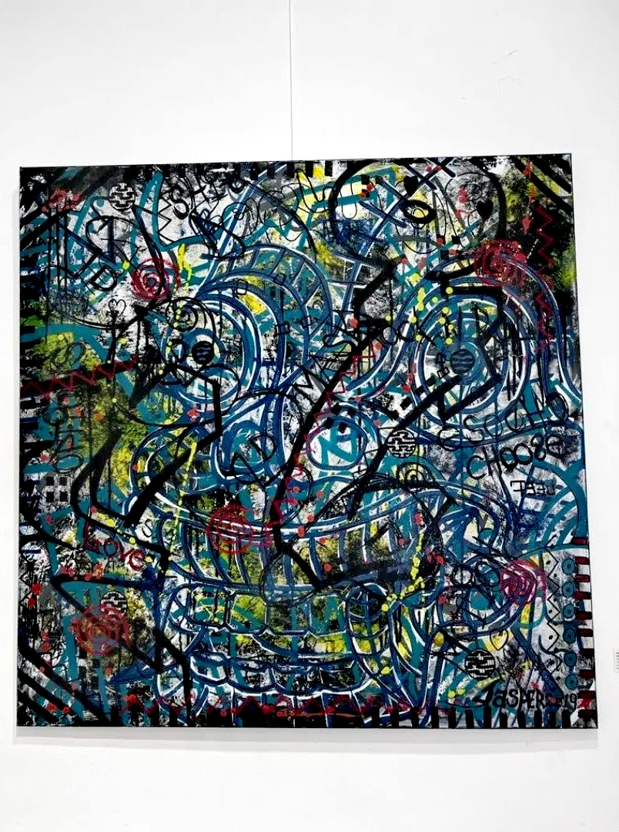

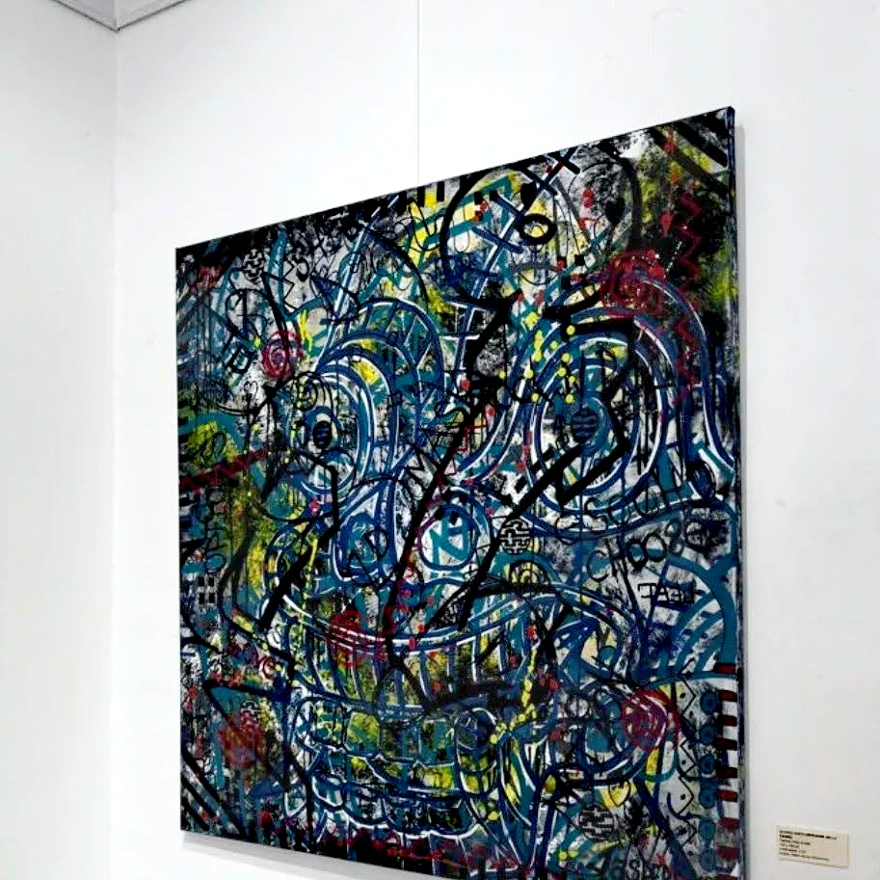

Exhibited painting ”Scared Insite” Acrylic and Oil Pastel on Canvas 100 x 100 cm.

Exhibited painting “Liberating”

Acrylic and Coal on Paper 46 x 34 cm.

